**DBMS LAB EXAM**

**Submitted By: AKSHAY JAIN**

**Reg. No: 17BCS002**

**DATABASE TABLE**

1. **Accident**

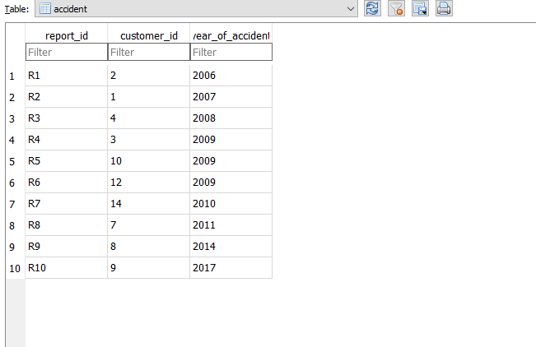

1. **Customer**

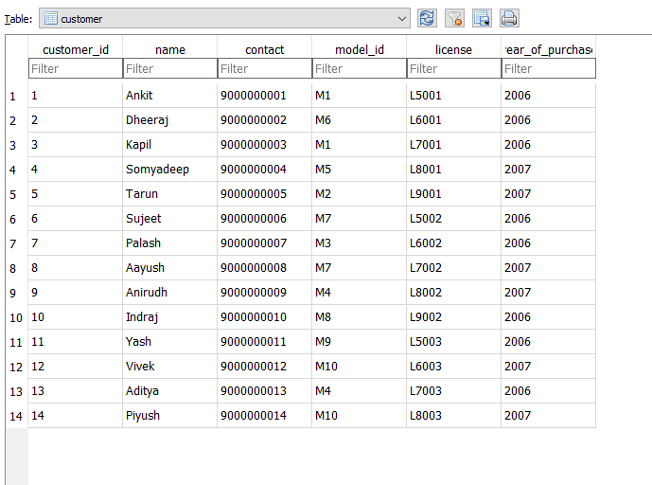

1. **Insurance_Claim_record**

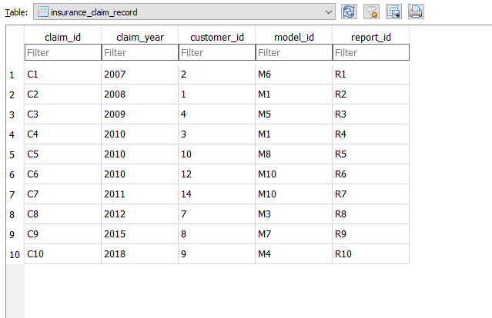

1. **Insurance_record**

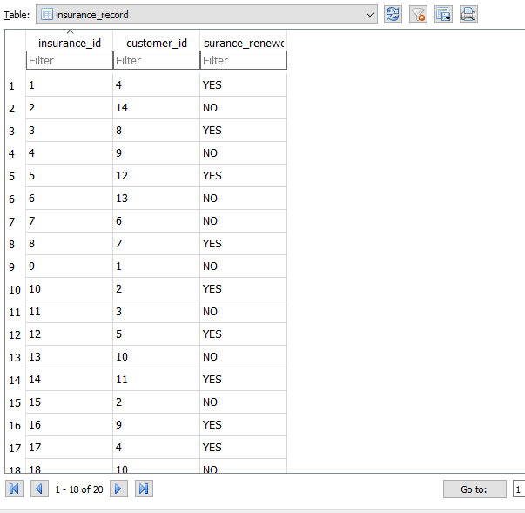

1. **Vehicle**

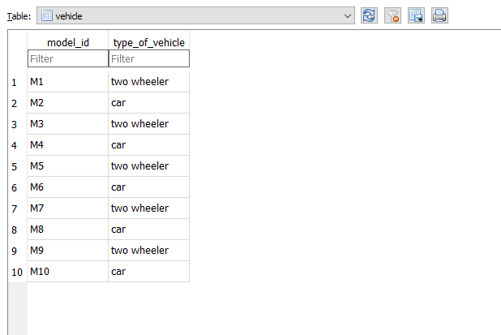

**Query 1:**

SELECT COUNT(customer.customer_id) FROM customer, accident

WHERE customer.customer_id = accident.customer_id

AND accident.year_of_accident = 2009

AND customer.model_id in ('M2','M4','M6','M8','M10')

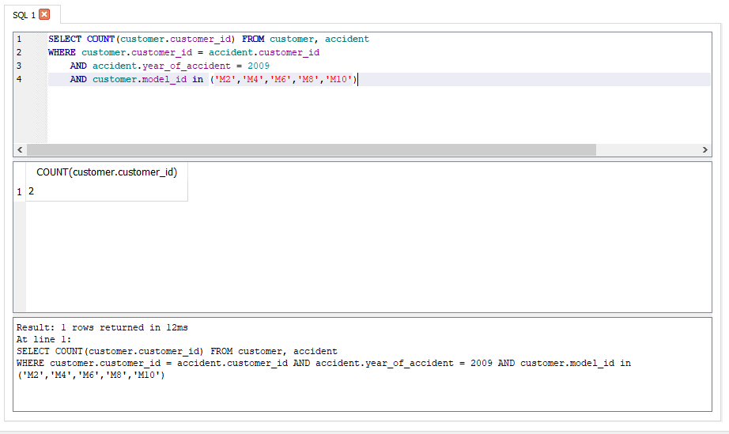

**Query 2:**

SELECT * FROM insurance_record

WHERE insurance_id BETWEEN 11 AND 20

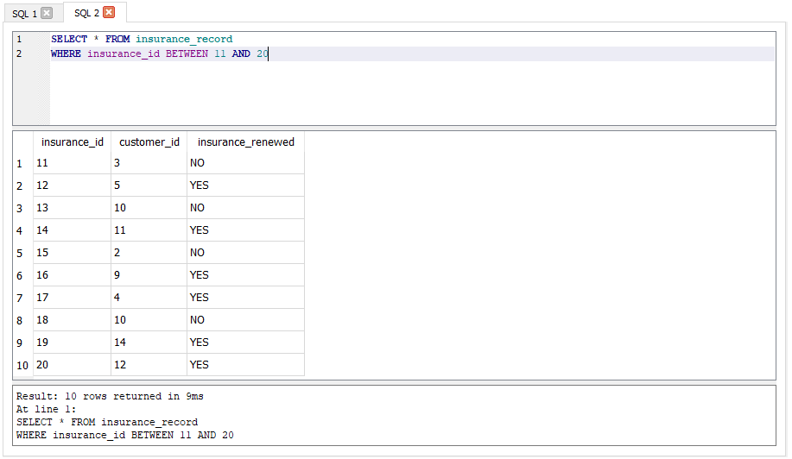

**Query 3:**

SELECT * FROM insurance_claim_record

WHERE claim_year IN ('2010', '2018') AND model_id IN

(SELECT model_id FROM vehicle WHERE vehicle.type_of_vehicle = "two wheeler")

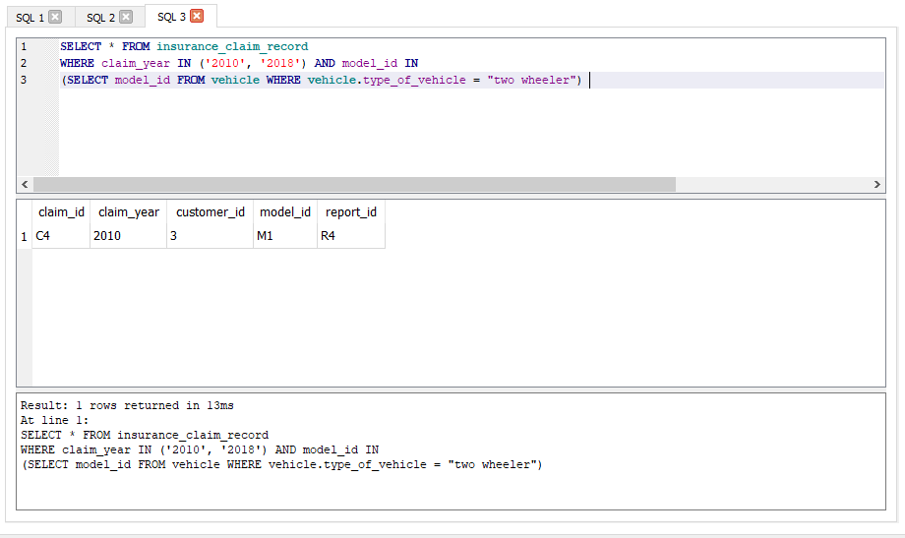

**Query 4:**

SELECT customer_id,customer.model_id, customer.license FROM customer

WHERE customer.year_of_purchase = '2006'

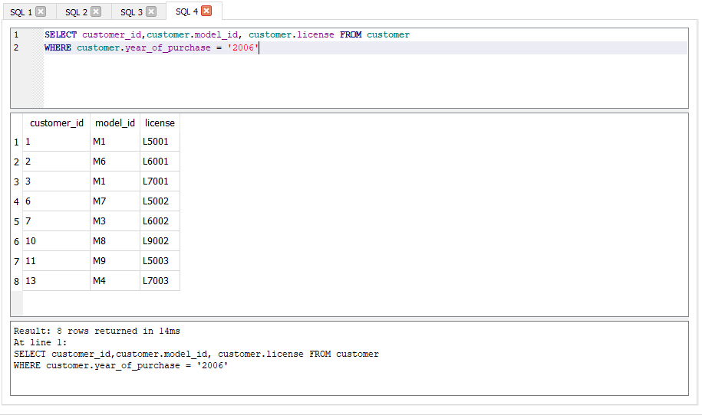

**Query 5:**

SELECT customer.customer_id, accident.report_id,customer.name, customer.license, customer.model_id,

customer.year_of_purchase,

insurance_claim_record.claim_id, insurance_claim_record.claim_year,

insurance_record.insurance_id, insurance_record.insurance_renewed

FROM accident, customer, insurance_claim_record, insurance_record

WHERE accident.customer_id = 1

AND insurance_claim_record.customer_id = 1

AND customer.customer_id = 1

AND insurance_record.customer_id = 1

